This document describes the verification guide for the changes done during the **JOHN HANCOCK - PROJECT COEUS ADMIN RELEASE ASSEMBLY** challenge.

1. Make sure you have deployed the application correctly following the “Deployment Guide.md” at root folder
2. Make sure you have inserted test data using **\TestFiles\TestData.sql**

Now you can verify the each issues.

1. <https://gitlab.com/tc-jh/jh-coeus-admin/issues/12>

Note: to replicate this issue easily please deploy the API in debug mode of VS and add break point in controller so that you can see the percentage.

Please check the issue detail to verify.

1. <https://gitlab.com/tc-jh/jh-coeus-admin/issues/20>

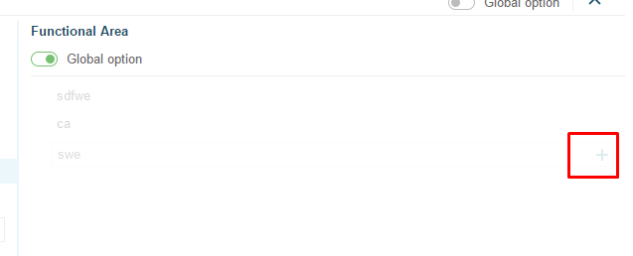

Now, you won’t be able to click the add icon.

1. <https://gitlab.com/tc-jh/jh-coeus-admin/issues/25>

Now you cannot insert the alphabets only number is accepted. As well as the value of percentage is save in addition to name.

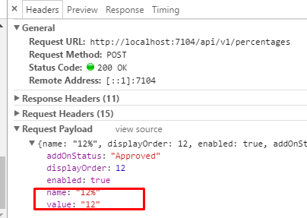

Also, the percentage value should be 1 to 100. Otherwise following alert will be shown

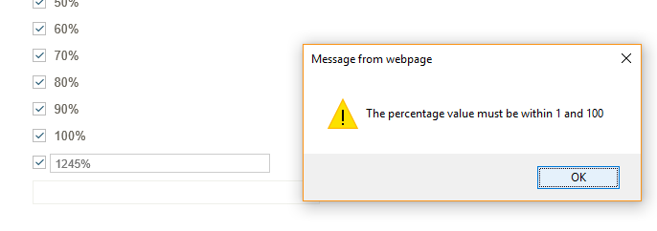

1. <https://gitlab.com/tc-jh/jh-coeus-admin/issues/27>

It is fixed, see the detail for verification.

1. <https://gitlab.com/tc-jh/jh-coeus-admin/issues/39>

It is fixed, see the detail for verification. Issue occurred when there is no core-processes as below 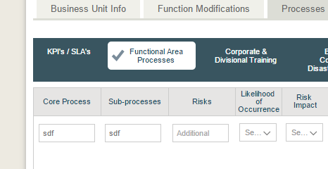

1. <https://gitlab.com/tc-jh/jh-coeus-admin/issues/44>

Fixed, now you can edit the risks as well, so when there is no risk value entered, a textbox will be shown so that you can update it.

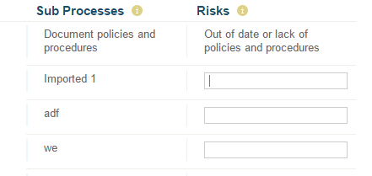

1. <https://gitlab.com/tc-jh/jh-coeus-admin/issues/45>

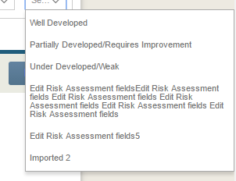

1. <https://gitlab.com/tc-jh/jh-coeus-admin/issues/48>

This is not applicable to master list but for other it is already saved on database which is working fine. Confirmed in <https://apps.topcoder.com/forums/?module=Thread&threadID=896709&start=0>

1. <https://gitlab.com/tc-jh/jh-coeus-admin/issues/53>

Check the issue detail to verify.

1. <https://gitlab.com/tc-jh/jh-coeus-admin/issues/54>

Check the issue detail to verify.

1. <https://gitlab.com/tc-jh/jh-coeus-admin/issues/55>

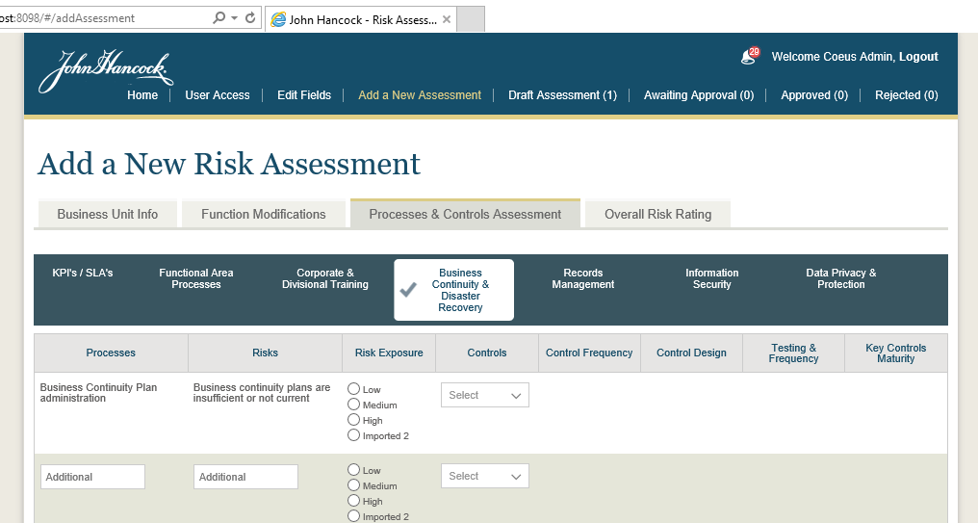

1. <https://gitlab.com/tc-jh/jh-coeus-admin/issues/57>

Check the issue detail to verify.

1. <https://gitlab.com/tc-jh/jh-coeus-admin/issues/59>

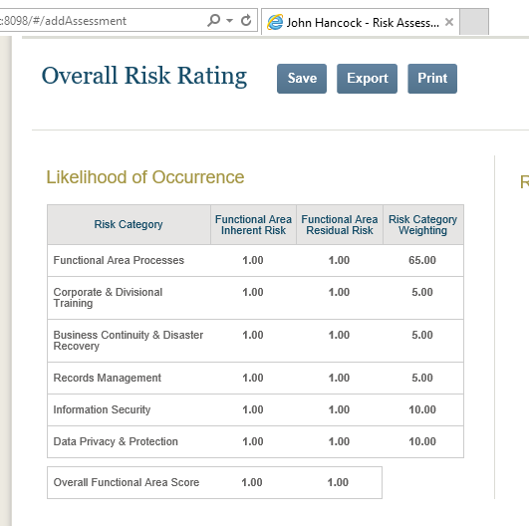

1. <https://gitlab.com/tc-jh/jh-coeus-admin/issues/60>

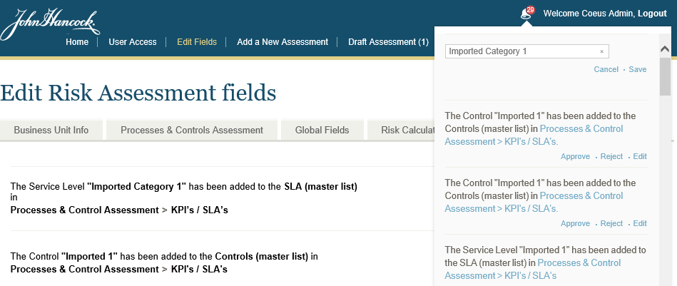

1. <https://gitlab.com/tc-jh/jh-coeus-admin/issues/61>

Fixed, now you can only add up to 100.

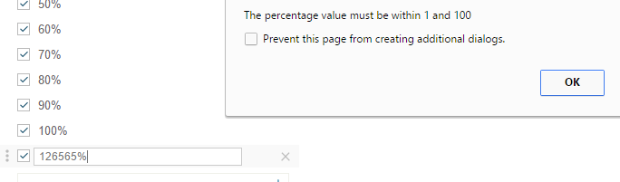

1. <https://gitlab.com/tc-jh/jh-coeus-admin/issues/63>

Fixed, please check issue detail to verify.

1. <https://gitlab.com/tc-jh/jh-coeus-admin/issues/64>

Fixed, please check issue detail to verify. Now you cannot click the ‘plus’ button or ‘press enter’ twice or more to create duplicate entries.

1. <https://gitlab.com/tc-jh/jh-coeus-admin/issues/74>

Create assessment using owner and submit for review then login with admin, now go to the detail you can see the reject and approve button similar to the approver.

1. <https://gitlab.com/tc-jh/jh-coeus-admin/issues/75>

It is saved on global variable so now until full page refresh the selection will be maintained.

1. <https://gitlab.com/tc-jh/jh-coeus-admin/issues/76>

Only implemented on master list as it can go very long.

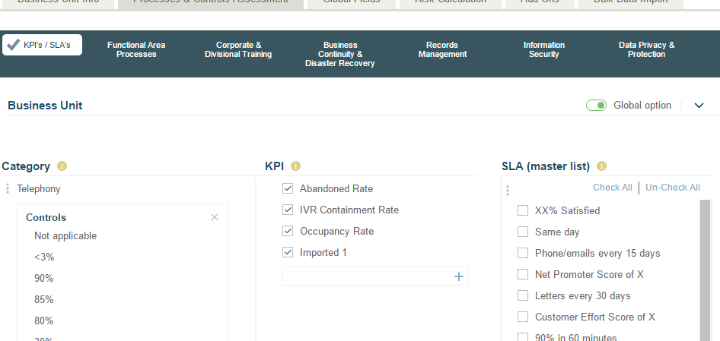

1. <https://gitlab.com/tc-jh/jh-coeus-admin/issues/78>

Final fixes.

1. <https://gitlab.com/tc-jh/jh-coeus-admin/issues/79>

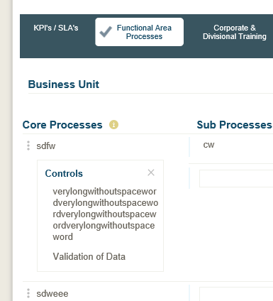

1. <https://gitlab.com/tc-jh/jh-coeus-admin/issues/82>

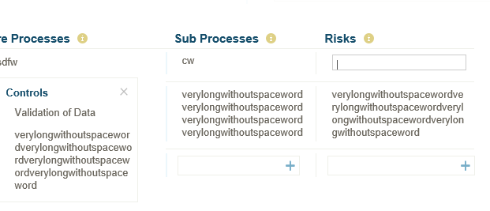

1. <https://gitlab.com/tc-jh/jh-coeus-admin/issues/83>

Fixed, no spaces and text will be accepted on risk calculation only integer or decimal value is allowed depending upon type. Please check the issue detail to verify

1. <https://gitlab.com/tc-jh/jh-coeus-admin/issues/95>

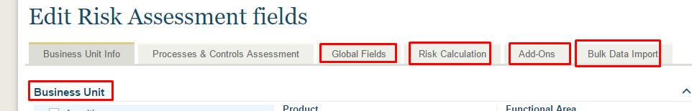

1. <https://gitlab.com/tc-jh/jh-coeus-admin/issues/96>

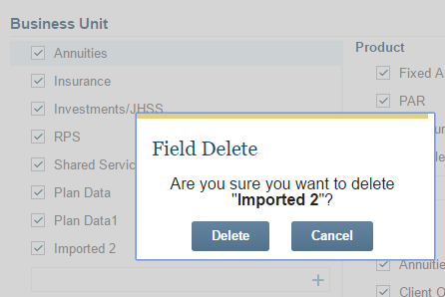

1. <https://gitlab.com/tc-jh/jh-coeus-admin/issues/97>

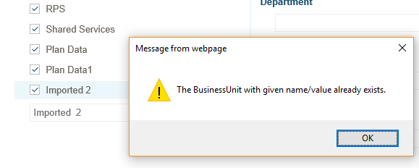

1. <https://gitlab.com/tc-jh/jh-coeus-admin/issues/98>

Final fixes.

1. <https://gitlab.com/tc-jh/jh-coeus-admin/issues/99>

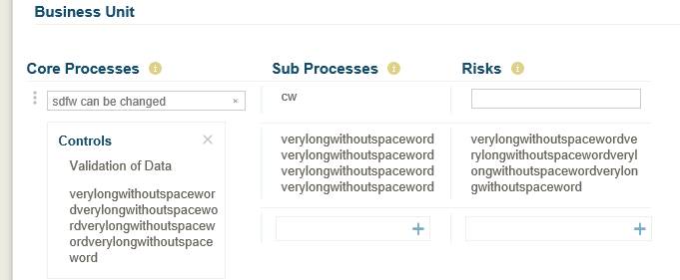

* Double click the name to edit and press “enter” to save the changed value.
* Verify Sub processes and risks can also be edited
* Verify text of column heading

1. <https://gitlab.com/tc-jh/jh-coeus-admin/issues/100>

* Curriculum/Process and risks can be edited for last 4 tabs.
  + Double click to the text to edit and press “enter” to save the changed value.
* Verify risk can be updated every time

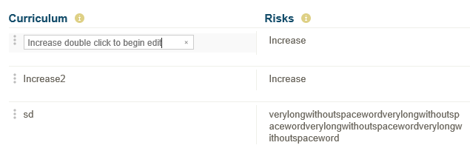

1. <https://gitlab.com/tc-jh/jh-coeus-admin/issues/101>

Try to change the value of risk category it will show confirmation message if sum is not 100.

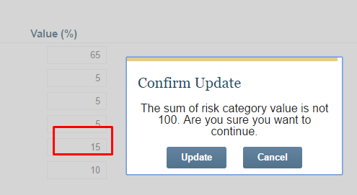

Press “Update” to continue update or “Cancel” to cancel the changes.

If the changed value is not within 1 and 100, the value will be not saved.

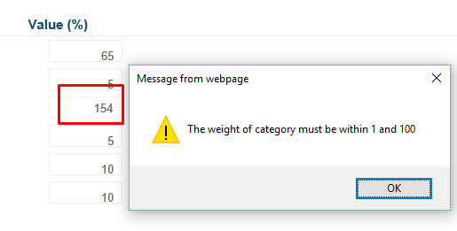

Verify the Risk Exposure now only accepts integer

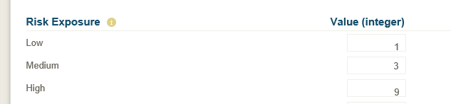

1. <https://gitlab.com/tc-jh/jh-coeus-admin/issues/102>

To create add on, please check “**9 Add On Creation**” in “**Docs\verfication guides\Admin Frontend assembly Part 2 Verification Guide.docx**”

1. <https://gitlab.com/tc-jh/jh-coeus-admin/issues/103>

**Bulk Data Input tab**

The bulk data input tab is used to add/update multiple fields value using the excel file. The format of file can be downloaded from the same tab by clicking “Download Template Sample” link as shown in below image

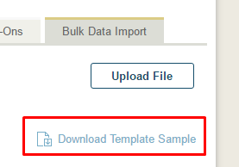

Now, you can add the different fields based on the sheet name. Each sheet name represents a field type.

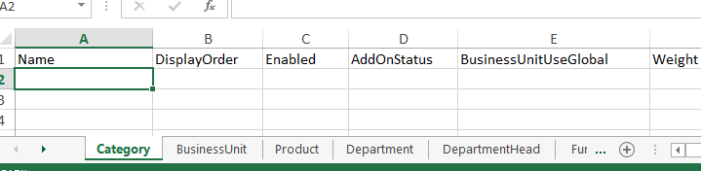

Don’t modify the header and sheet name. You can enter the detail for your field values and upload the saved file using same tab by clicking the “Upload File” button. This will open a popup where you can drop the file or select the file.

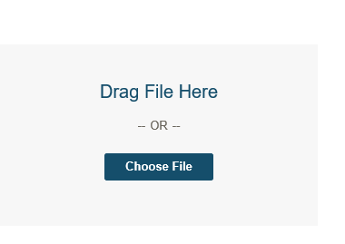

The file will be uploaded to the server. If file is valid and data is in correct format then all field values will be saved. If name of fields is already found then the existing will be updated else new record will be created.



If there is any error while saving the data, either file is invalid or data is invalid then the failed screen is shown with error message.

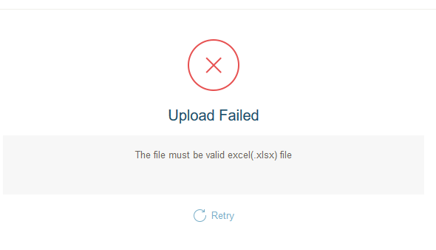

You can click on “Retry” link to try again.